# Overview

During this exercise you will create a window containing text, and modify your program to display that text instead of the current pop-up message box.

# Resources

* [Synergy DBL Language Reference](https://www.synergex.com/docs/index.htm)
* [Synergy Best Practices - Coding Standards](http://jobfunc2.cu.net/Job%20Functions/Programmer/Programmer%20Handbook/Tims%20Best%20Practices%20-%20Standards/Synergy%20Best%20Practices%20-%20Coding%20Standards.docx)
* [Traditional Synergy in Visual Studio - CU Wiki](http://echo.cu.net/cuwiki/Traditional_Synergy_in_Visual_Studio)
* [Traditional Synergy in Visual Studio Common Terminology - CU Wiki](http://echo.cu.net/cuwiki/Traditional_Synergy_in_Visual_Studio_Common_Terminology)
* [Debugging (TSVS) - CU Wiki](http://echo.cu.net/cuwiki/Debugging_(TSVS))

# Exercise

To complete this exercise you should complete the following steps, in the order shown:

1. Using Visual Studio, open the previously created “Demo” project.
2. Using Visual Studio, Tools, Synergy Composer:

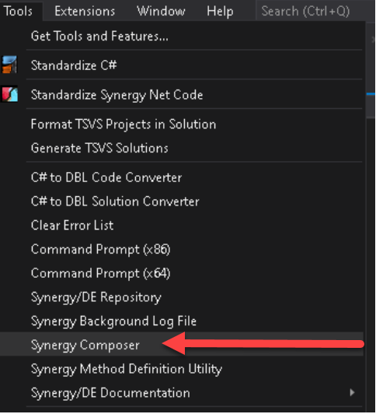

1. In Synergy Composer, File, Save Script As:

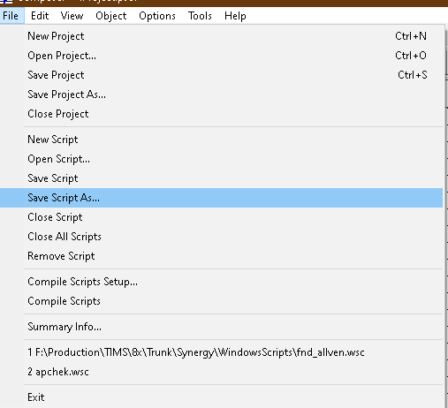

1. Save the script as **Synergy\WindowsScripts\Demo.wsc**
2. In Synergy Composer, Object, Add:

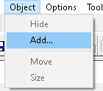

1. In Synergy Composer, Add Object, add a window:

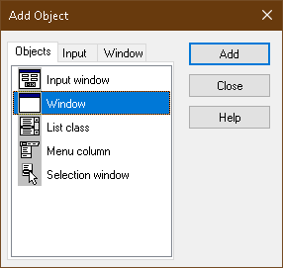

1. Select the “Long” tab in the “Properties” window and set the following:
   * Border: Off
   * Name: STTWelcome
   * Under User data sets, hit the ellipsis (…).
   * In the User Data Sets dialog, add the following:
     + .user 10, 80
     + .data 1, “Welcome to the program”
     + .data 2, “Press OK to exit”

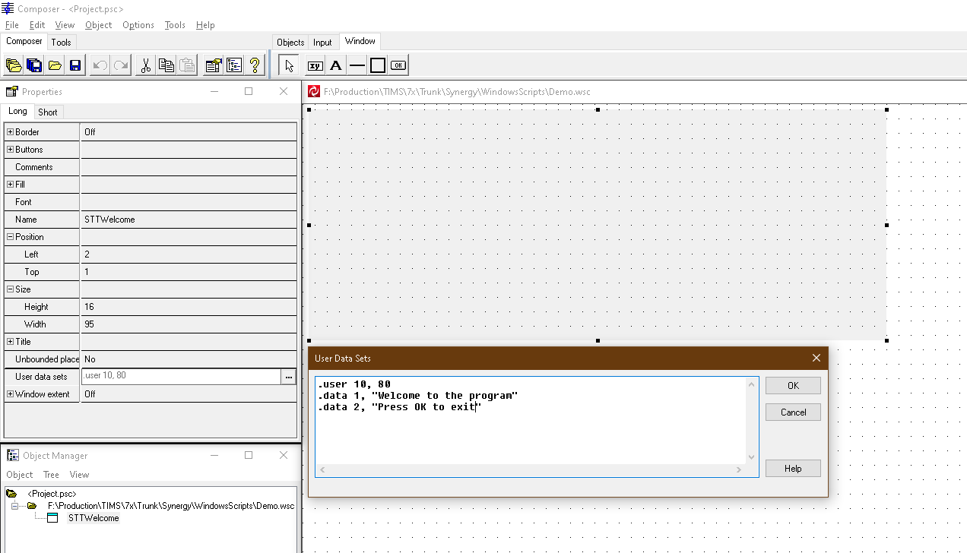

1. Compile the script using: **Synergy\BuildSynergyWindowsLibrary.bat**
2. Using Visual Studio, open “Demo.dbv”.
3. Edit your program, replacing the code which pops up the message box with code that does the following:
   1. Loads, but does not place the “STTWelcome” window.
   2. Retrieves the user data string (using **CU_BLD**).
   3. Display the retrieved text from the user data string and waits for user input.
4. Compile, link and run the program.

# Discussion

Displaying a pop-up message box is essential in this exercise, as it is the only thing that performs any kind of keyboard input. Without this, there would be no screen update, so the program would not display anything to the screen and would simply run through and terminate, without displaying anything to the screen.